Selection and indexing
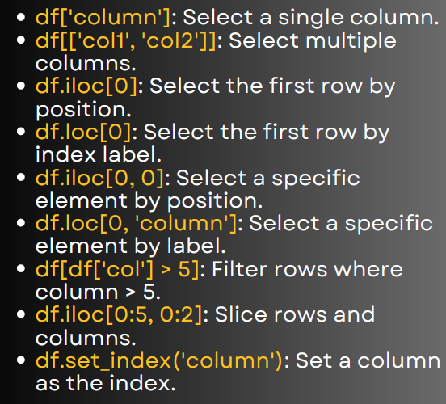

1. Select a single column
import pandas as pd
data = {
'Name': ['A', 'B', 'C', 'D'],
'Age': [23, 25, 22, 28],
'Salary': [50000, 60000, 55000, 65000]
}
df = pd.DataFrame(data)
print(df['Age'])
Output: A Series of the "Age" column.

2. Select multiple columns
print(df[['Name', 'Salary']])
Returns only the Name and Salary columns.

3. Select the first row by position (using .iloc)
print(df.iloc[0])
Returns row at index 0.

4. Select the first row by label (using .loc)
print(df.loc[0])
Same as above, since our index is default (0,1,2,3).

5. Select a specific element by position
print(df.iloc[0, 0])
Returns the element in 1st row, 1st column ('A').

6. Select a specific element by label
print(df.loc[0, 'Salary'])
Returns salary of first row → 50000.

7. Filter rows based on condition
print(df[df['Age'] > 23])
Returns all rows where Age > 23.

8. Slice rows and columns
print(df.iloc[0:2, 0:2])
Returns rows 0–1 and columns 0–1 (subset of DataFrame).

9. Set a column as index
df2 = df.set_index('Name')
print(df2)
Now "Name" becomes the index instead of numbers.

